Calaway Park
Gardening Tips: Seedling Starting and Care

Soil is of utmost importance! Use a crumbly soil, mixed
with compost or additives when possible, that holds together when squished, but breaks up easily.

Start with moist soil, damp to the touch but not sopping.
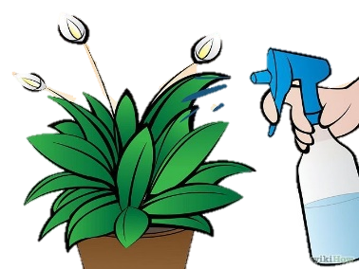

Gently mist or water the soil daily – seedlings
require warm, moist soil to germinate.

For container gardens, germinate seeds
between wet paper towels in a baggie to ensure
the viability of the seeds. Once sprouted,
transplant into a lightweight soil mix.

Remember to be calm and patient, gardening is relaxing! Notice the small changes and make adjustments accordingly with watering and fertilizing. Visit the garden often as the changes are subtle yet rapid.

